Descriptive Adjectives

🔹 What Are Descriptive Adjectives?
# Source: AI Source: Provided by: [Data Path: Persons Table -> ID Column: 1, Name_En Column: Motasem Essam] -> From: [Chatgpt (GPT-4-turbo)] on [7/27/2025]
Descriptive adjectives are adjectives that describe the qualities or features of a noun or pronoun.
They tell what kind, how something looks, feels, tastes, sounds, or acts.

✅ Examples of Descriptive Adjectives
# Source: AI Source: Provided by: [Data Path: Persons Table -> ID Column: 1, Name_En Column: Motasem Essam] -> From: [Chatgpt (GPT-4-turbo)] on [7/27/2025]
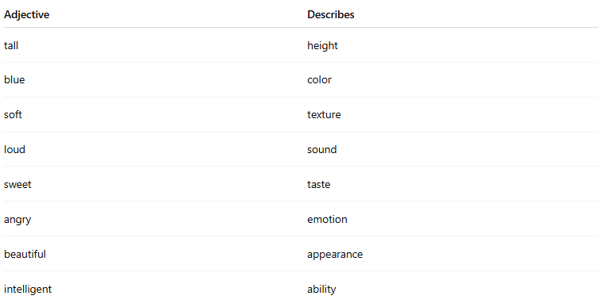
Adjective | Describes
tall | height
blue | color
soft | texture
loud | sound
sweet | taste
angry | emotion
beautiful | appearance
intelligent | ability

📚 Examples in Sentences
# Source: AI Source: Provided by: [Data Path: Persons Table -> ID Column: 1, Name_En Column: Motasem Essam] -> From: [Chatgpt (GPT-4-turbo)] on [7/27/2025]
- She has a beautiful smile.
- The old man walked slowly.
- We saw a huge elephant at the zoo.
- That cake tastes delicious.
- It’s a cold morning today.

🧠 Key Point:
# Source: AI Source: Provided by: [Data Path: Persons Table -> ID Column: 1, Name_En Column: Motasem Essam] -> From: [Chatgpt (GPT-4-turbo)] on [7/27/2025]
Descriptive adjectives add detail and make writing more vivid.
Without: She wore a dress.
With: She wore a long, red, silk dress.

